**ASSIGNMENT-4**

|  |  |
| --- | --- |
| TeamID | PNT2022TMID52225 |
| MaximumMarks | 2Marks |

# **Question1:**

# *Write code and connections in wokwi for the ultrasonic sensor.

*Write code and connections in work for ultrasonic sensor.Whenever distance is lessthan 100cms send"alert"toibmcloudanddisplayindevicerecentevents.

**Code:**

#define ECHO_PIN 2

#define TRIG_PIN 3

void setup() {

**Serial**.begin(115200);

  pinMode(LED_BUILTIN, OUTPUT);

  pinMode(TRIG_PIN, OUTPUT);

  pinMode(ECHO_PIN, INPUT);

}

float readDistanceCM() {

  digitalWrite(TRIG_PIN, LOW);

  delayMicroseconds(2);

  digitalWrite(TRIG_PIN, HIGH);

  delayMicroseconds(10);

  digitalWrite(TRIG_PIN, LOW);

  int duration = pulseIn(ECHO_PIN, HIGH);

  return duration * 0.034 / 2;

}

void loop() {

  float distance = readDistanceCM();

  bool isNearby = distance < 100;

  digitalWrite(LED_BUILTIN, isNearby);

**Serial**.print("Measured distance: ");

**Serial**.println(readDistanceCM());

delay(100);

}

WOKWI LINK : https://wokwi.com/projects/347117330309841491

**Solution :**

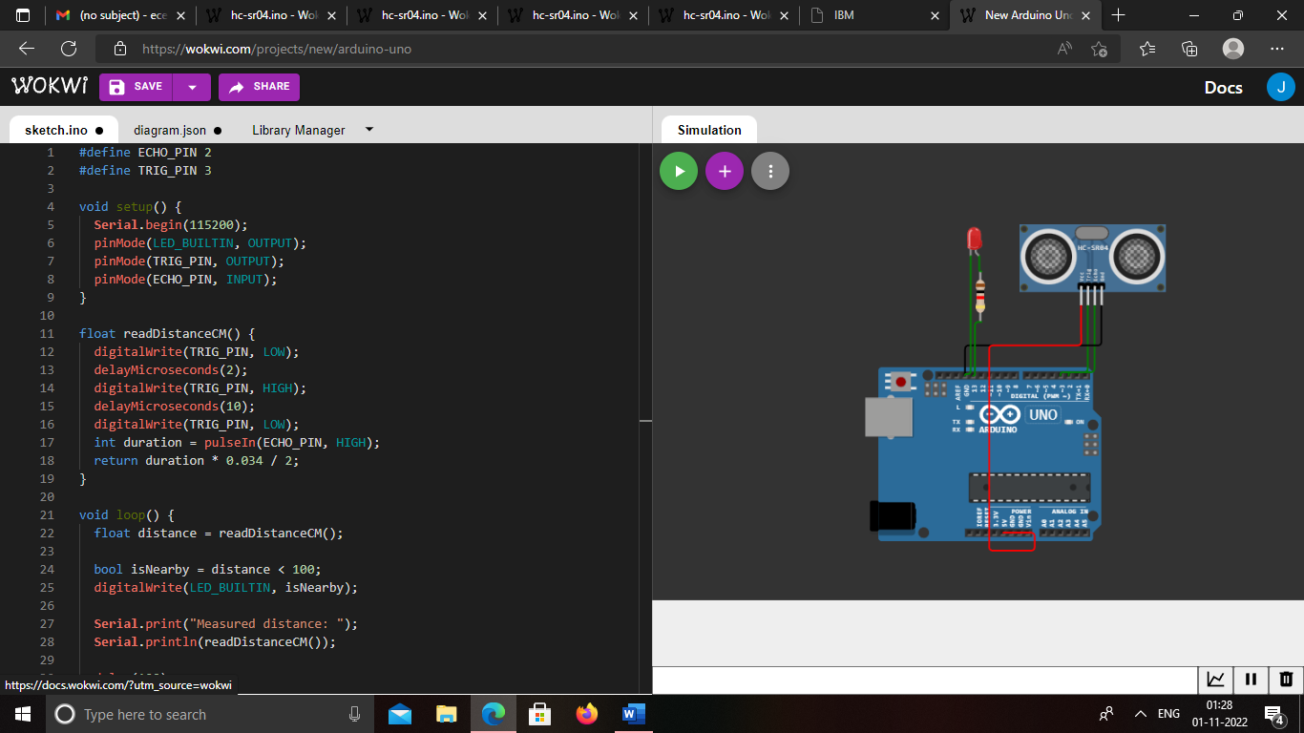

**Solution run:**

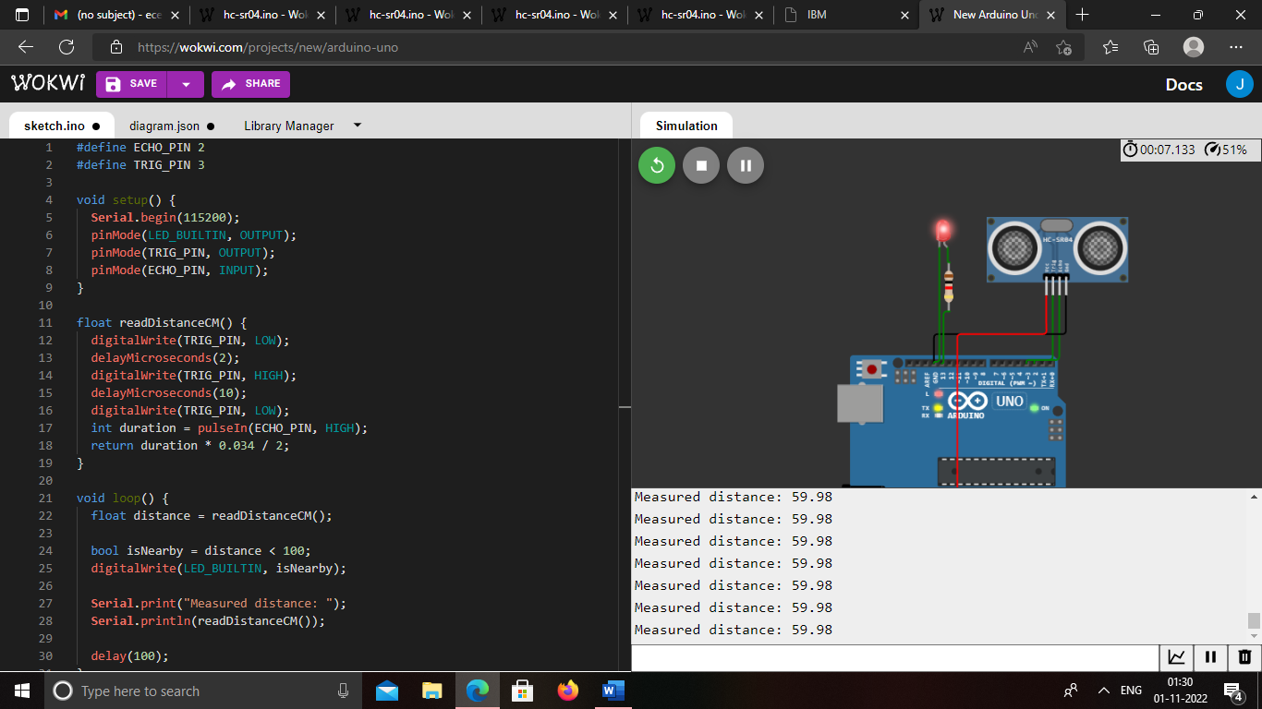

OUTPUT:

DATA IS SENT TO IBM CLOUD WHEN NO OBJECT IS DETECTED

:

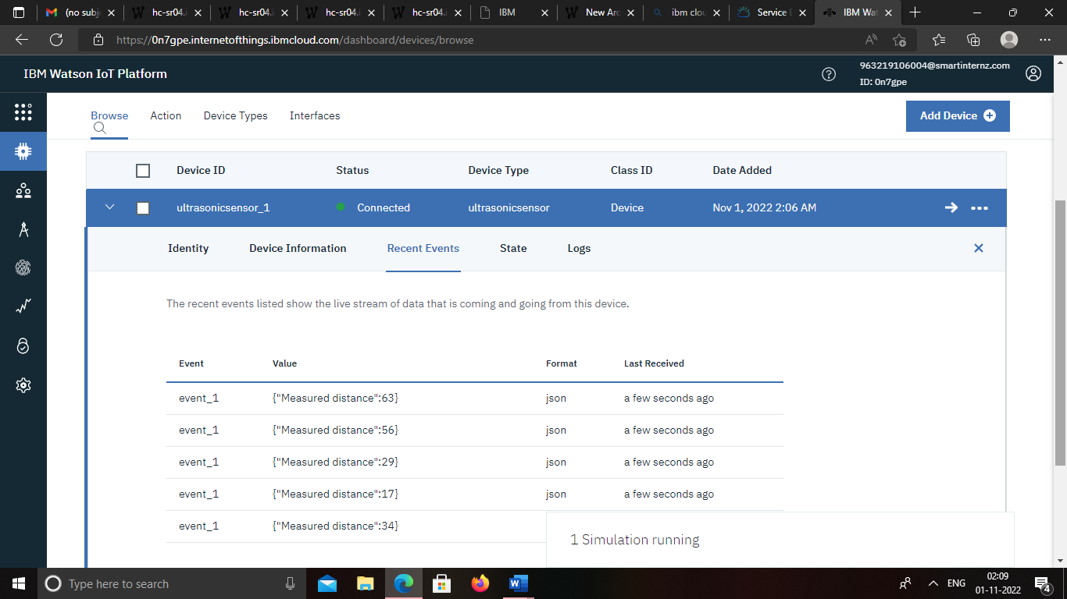

When no object is dedected 